**Airborne Wildlife Aircraft Strike Hazard**

**ABSTRACT**

*Wildlife(Bird) collisions with aircrafts have been increasing in the United States and all across the globe. As the technology from the day-to-day life has been growing, the threat to the wildlife is also increasing.*

*There are various reasons for a aircraft-bird-clash like the atmospheric unpredictability, bird migrations and so on. Hundreds of birds collapse because of the airstrikes. There has been no track of such data and also the bird species that collide in that specific air range are being driven towards extinction.*

*With that in mind, this paper aims to create a database that produces data regarding the existing birds count, number of birds that died because of the aircraft strikes, so as to provide tangible record of existing and endangered airborne wildlife.*

# Keywords

Wildlife, birds, aircrafts, airstrike, research, sanctuaries, bird-strike hazard, database, endangered, wildlife protection, bird-aircraft-collisions, airports, airlines, altitudes, effective damage, state.

# INTRODUCTION

The number of bird strikes reported per year to the FAA *(Federal Aviation Administration)* increased remarkably from about *1,800* in 1990 to *16,000* in 2018. Numerous birds are being dead and aircrafts are being damaged.

As steps to conserve wildlife are being taken, with expanding airborne wildlife, increase in

number of aircraft movements, a trend towards quieter, yet faster aircraft designs, and growing

outreach of the aviation community, all these have contributed to the observed increase in

reported (wildlife) bird strikes. As a result of the widespread increase in wildlife strikes, there

has been greater emphasis on **‘**

wildlife aircraft strike hazard research and airfield wildlife

management**’.**

For over two decades, the FAA *(Federal Aviation Administration)*

and the USDA conducted

concerted efforts to collect accurate data on airborne wildlife strikes, to better understand the

scope and nature of the problem. These strike data provide a scientific foundation for

management programs to mitigate risk. A major part of collecting the data is providing the

general public with an easy way to submit strike reports in a consistent format. This continues to

be accomplished through the use of the FAA’s *wildlife hazard mitigation* website ( https://wildlife.faa.gov/) and the FAA’s Wildlife Strike Database.

# Usage of Data and Target user:

The data collected by FAA and USDA is used to conduct a concerted effort to collect accurate data on wildlife strikes. Most of the data was available on files, which is not useful for processing or any information extraction. So it will be digitalized and a database will be made. The data is going to be used by an ***app***, which is used as an interface by the

pilots, airline crew, or researchers to *report the bird strikes*, and process the data for any of the following purposes.

This database targets to help:

● Aviation to avoid any damage to aircrafts or planes and to avoid major crashes causing

life loss.

● Aviation management to reduce the cost for damage recovery.

● Researchers to run simulations and find possible new routes where the estimated damage can be minimum or zero.

● Wildlife conservation community.

## Updating data in future

The data is going to be updated on a daily basis reported by the aircraft pilots or airlines groups. Each record of the data consists of information about the aircraft details, flight path of aircraft, incidence time of bird strike, specific details of the birds, the details on the damages caused if any (for example: the engine failures, propeller damages etc).

**2.2What kind of queries will be asked?**

***Sample queries:***

● Find the number of bird strike incidents for each airport upon take-off or climb.

● Find the airports that had the most bird strike incidents (during any flight phase).

● Find the number of bird strike incidents by year. Includes all airlines.

# List of selected attributes from dataset:

***Bird-strikes Database:***

Record_id : INDEX_NR ( Individual record number )

Altitude : HEIGHT ( Feet Above Ground Level )

wildlife_struck_Actual : BIRDS_STRUCK

( Number of birds/wildlife struck )

Effect_impact : EFFECT ( Effect on flight )

Effect_damage : INDICATED_DAMAGE

( Indicates whether or not aircraft was damaged )

Flight_date : INCIDENT_TIME ( INCIDENT_DATE/ INCIDENT_MONTH /

INCIDENT_YEAR / TIME )

Phase_of_flight : PHASE_OF_FLT ( Phase of flight during which strike occurred )

Conditions_sky : SKY (Type of cloud cover, if any )

Remains_collected : REMAINDS_COLLECTED

( Indicates if bird or wildlife remains were found and collected )

Remains_sent : REMAINS_SENT ( Indicates if remains were sent to the Smithsonian Institution for identification )

Remarks : REMARKS ( Comments on strike incident )

Wildlife_id : SPECIES_ID ( International Civil Aviation Organization code for type of bird or other wildlife )

Warning : WARNED ( Pilot warned of birds/wildlife )

Cost : COST_REPAIRS ( Estimated cost of repairs of replacement in U.S.D )

Injuries : NR_INJURIES ( Number of people injured )

# Relational Schema Diagram

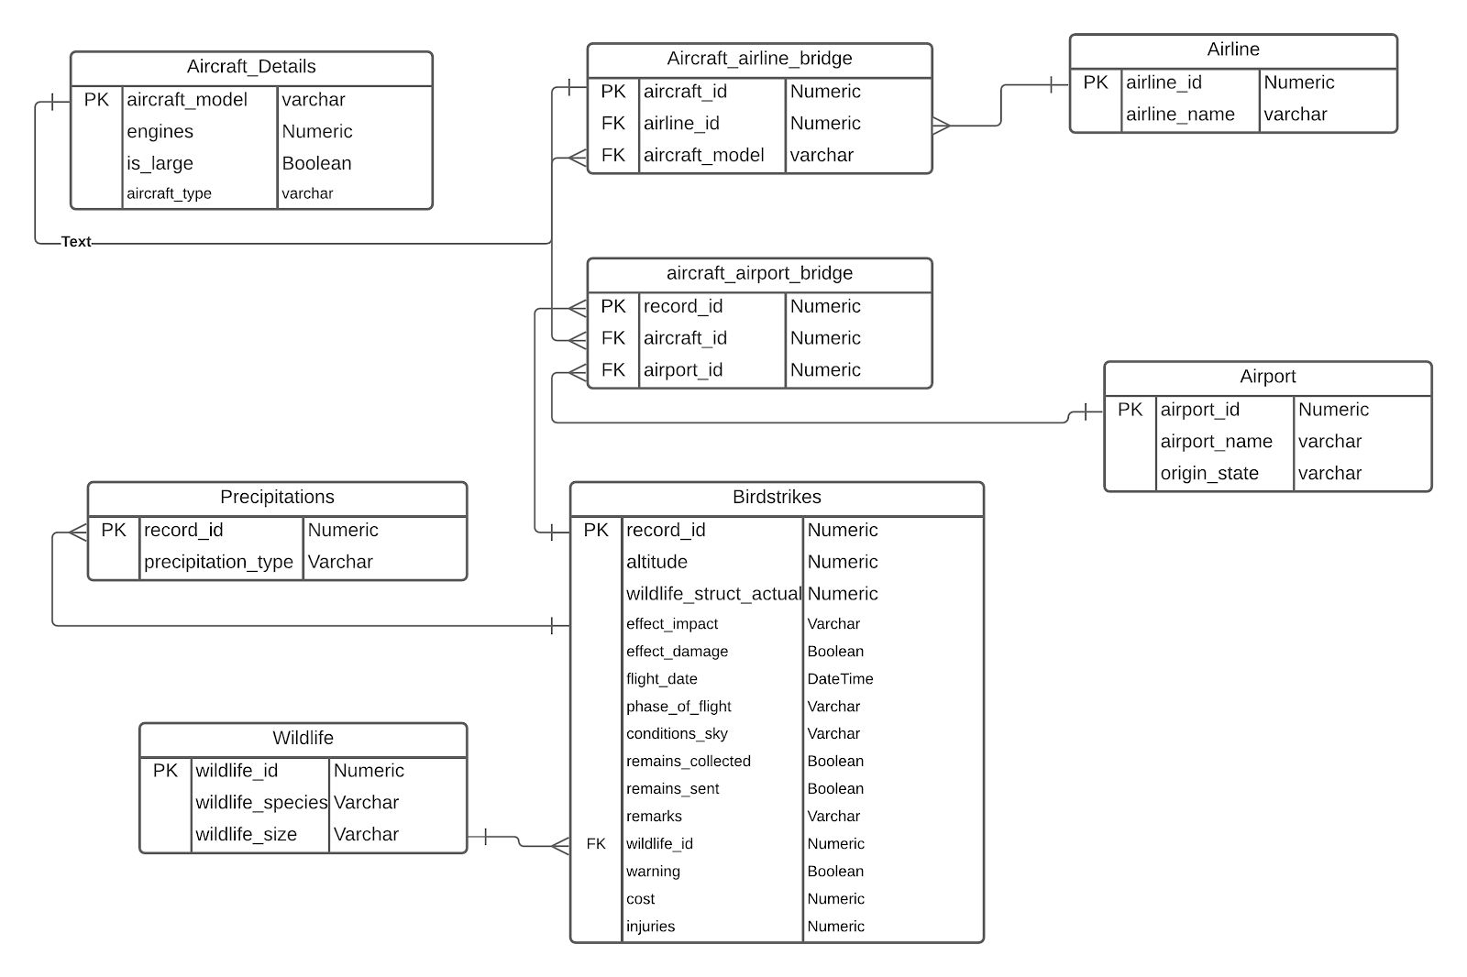

# On query for Aircraft Model:

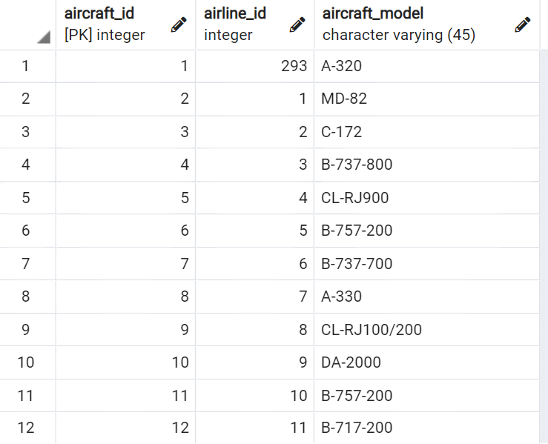

This table gives *aircraft ids - specific to each aircraft*.   
  *airline ids - To which airline it belongs to  
 aircraft model - Model of the aircraft*

**On query for Airport-Aircraft bridge details:**

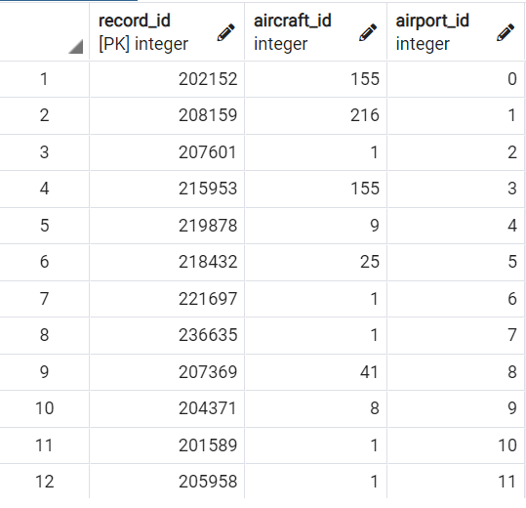

This table gives details regarding

*airport ids - Which airport an aircraft takes off from*.   
 *aircraft ids - Unique id for each aircraft aircraft model - Model of the aircraft*

**On query for Aircraft details:**

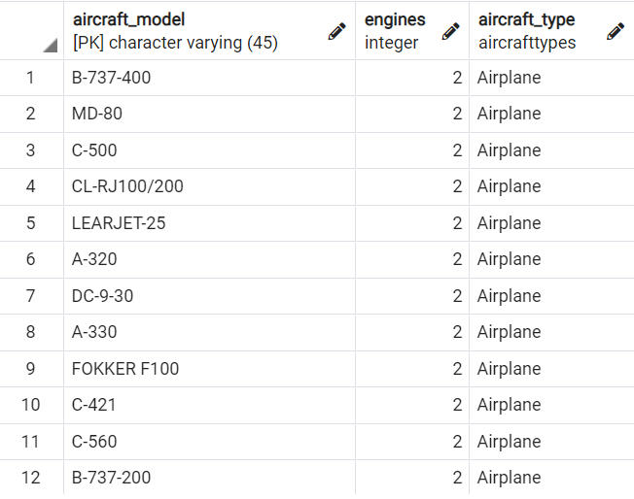

The aircraft details query provides

*Aircraft model - Model of the aircraft  
 engines - Number of engines in that aircraft  
 aircraft type - Which kind of aircraft does it belong to*

**On query for Airlines that provide aircrafts:**

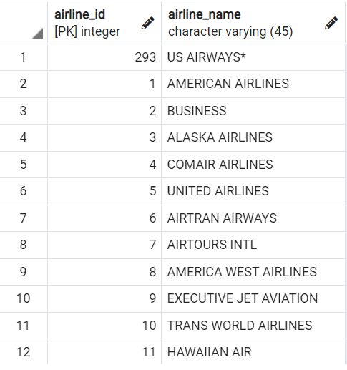

This table gives *airline ids - To which airline it belongs to  
 airline name - The name of the airline owning the aircraft*

**On query for Airports and their origin states:**

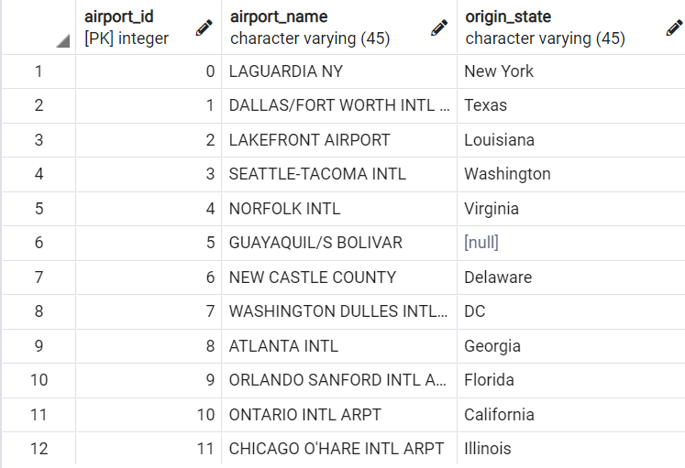

This table provides the details for :

*Airport Id - Unique ID for an airport  
 Airport name - Name of the airport  
 Origin State - State where the airport is located*

**On Query for bird-strike details:**

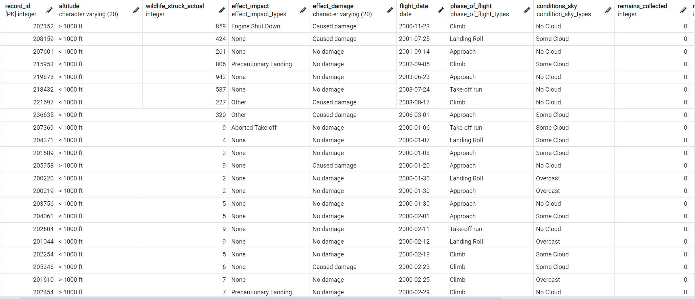

This table provides following details:

*Record id - Each record’s unique id  
Altitude - The height at which the flight flies  
Wildlife struck - Birds collided with the flight  
Effect Impact - How the collision effected  
Effect date - Date on which the incident took place  
Effect damage - Amount of damage dealt  
Phase of flight - In what phase of its flight the plane is  
Sky condition - Condition of sky  
Remains collected - Any remains of wildlife collected*

**On query for Wildlife Data :**

# wildlife

This table gives details regarding

*Wildlife ids - Unique ID given to each wildlife airborne animal*   
  *Wildlife species - Which species the wildlife belongs to  
 Wildlife size - Size of the animal/bird*

# Explanation and Assumptions in the Data Model represented above:

*Verifying* ***1NF***-

**.** Precipitation being one of the attribute representing the weather on the day of strike, has multi valued entries like ’*fog, rain, snow*’.

**.** Hence a **separate table** has been created to ensure *atomicity*.

**.** All other tables have single valued entities. So **1NF (First Normal Form)** is satisfied in other tables.

*Verifying* ***2NF -***

1. Table Aircraft_details has
   1. 1 primary key : Aircraft_model
   2. No partial dependencies are observed given one primary key.
2. Table Aircraft_Airline_Bridge has
   1. 1 primary key : Aircraft_model.
   2. No partial dependencies are observed.
3. Table Airline has
   1. 1 primary key : Airline_id.
   2. No composite keys. So no partial dependency observed.
4. Table Airport_Aircraft_Bridge has
   1. 1 primary key : Record_id.
   2. Since the rest are foreign keys, we do not have any partial dependencies here.
5. Precipitations table has:
   1. Record_id as primary key.
   2. Precipitation type is the only column in it, which is not partially dependent.
6. Airport table has
   1. One primary key - Airport_id
   2. There is no partial dependency over there, since both the attributes are dependent on the primary key.
7. The table Birdstrikes is entirely dependent on the record_id which involves all the factors that are noticed in the incident flight. There is no other candidate key to rely on. So the partial dependency is not present.
8. The table Wildlife has
   1. One primary key - Wildlife_id
   2. Wildlife_species and Wildlife_size are dependent on Wildlife_id and no partial dependency is observed.

So, all tables are in **2NF(2nd Normal Form).**

*Verifying* ***3NF*** -

1. In Aircraft_Airline_Bridge table,

The Functional Dependencies were:

**Aircraft_id ---> { Airline_name, Engine, Aircraft_model, Is_large, Aircraft_type }**

But it lead to **Transitive dependency** between Engine, Aircraft_type, Aircraft_model such that -

Aircraft_model ---> { Engine, Is_large, Aircraft_type }

Aircraft_type ---> { Engine, Is_large }

Airline_name ---> { Aircraft_type }

*Transitive Dependency*: A non-prime attribute describing another non-prime attribute.

**.** So in order to remove it, we created two different tables for **Airline_name** and **Aircraft_model** and compose **Airline**, and **Aircraft**_**details**. So the functional dependencies become -

**Aircraft_id ---> { Airline_id, Airline_id, Aircraft_model, }** - for Aircraft-Airline-Bridge Table

Aircraft_details table functional dependency:

**Aircraft_model ---> { Engine, Is_large, Aircraft_type }**

Airline Table Functional Dependency:

**Airline_id ---> Airline_name**.

1. Similarly, we had a table with aircrafts landing at and from a particular state and airport, had functional dependencies as :

**Record_id ---> { aircraft_id, airport_name, origin_state }**

**Airport_name ---> {origin_state }**

To avoid that, we created another bridge tables called Aircraft_airport_bridge and Airport. It has the below functional dependency.

*Aircraft_airport_bridge table*:

**Record_id ---> { aircraft_id, airport_id }**

*Airport table* :

**Airport_id ---> { airport_name, origin_state }**

All the tables now follow 3NF. Therefore **3NF (Third Normal Form)** is satisfied.

*Validating* ***BCNF*** *-*

The super keys for the relations in the schema are:

Aircraft details - {Aircraft_model }

Aircraft_airline_bridge - { Airline_id }

Airline - { (Airline_id), (Airline_name) }

Aircraft_airport_bridge - { (record_id), (record_id, aircraft_id),(record_id, airport_id) }

Airport - { (Airport_id),

(Airport_id, Airport_name),

(Airport_id, origin_state) }

Precipitations - { record_id }

Wildlife - { Wildlife_id, (Wildlife_id, Wildlife_species) }

Birdstrikes - {record_id} - *The minimal superkey*

From the above done table decompositions and the sets of super keys, the tables follow

1. Is in third normal form and
2. Obeys the super key / candidate key condition.

So the relations are in ***BCNF****(* ***Boyce-Codd Normal Form****)*.

**Additional changes to satisfy the normalization:**

• An aircraft model would be independent of airport or airline or the possible bird strike and hence have created a separate class for it.

• Similarly the airline and airport are independent entities as well and hence have created respective classes for them.

• The generic features representing the bird strike, like the impact of the strike on the aircraft, the cost are kept in a single table as they all are dependent on the trip of the flight that day.

• There is a separate table representing the wildlife, which takes the details of the species and the size.

• A couple of bridge tables are included to ensure that the airport and the flight details are connected.

**.** As we can see, also, the airline, and the airline_model are connected.